**Hublet iOS Mobile app**

Table of Contents

[Introduction 2](#_Toc457323464)

[Scope of work 2](#_Toc457323465)

[Features 2](#_Toc457323466)

[Sample App Screenshots 4](#_Toc457323467)

[How the app will work? 5](#_Toc457323468)

[Critical functionalities 7](#_Toc457323469)

[Challenges for Development 7](#_Toc457323470)

[Queries & Understandings 8](#_Toc457323471)

# Introduction

Hublet app enables private landlords to let out their property directly to a tenant with no cost to them. It is purposely made simplistic for both parties to navigate as well as attempting to keep the process enjoyable.

Landlords are able to upload and input basic information about their property.

A prospective tenant can search the database for properties that suit. Properties are listed in a Tinder style swiping system, swiping left to dismiss a property and swiping right to ‘connect with the landlord’. Clicking into a property will show further photos and more information on that specific property.

Tenants are able to search the database for properties but will not be able to use certain functions until they are fully registered. Upon registering and swiping to ‘connect with the landlord’ a notification will be sent to the landlord that they have a ‘match’. The landlord will be able to click on that tenants profile to get further information on them and decide whether they would like to make further contact or dismiss the enquiry. Again this will involve swiping left or right. Swiping right will make further contact and a messenger service will appear for the two parties to discuss further, raise questions and organise a viewing if required.

Upon a letting being agreed landlords can use the in app services to create a contract and undertake a credit check on the tenant.

# Scope of work

Private landlords can reach out to tenants directly through the app without worrying about the real estate agents with no extra cost. They can also communicate with each other inside the app effortlessly.

# Features

* The app will be developed for ***iPhone*** platforms
* This app will be listed as free to download & install on the iTunes
* There will be two types of user one is landlord and another one is Tenant
* The app will use the GPS to get the user’s current location to view the property listing near to the user
* After installing the app the user will be able to view all the Property listing available for Rent near to the user’s location in an interactive way. There will be different views for listing of property with icons to select at the top
  + Map view with pushpins and count of property
  + Card view like the Tinder app so that user can swipe to select and dismiss
  + List view with a scroll including property image and short description
* User can narrow down the property listing by doing search with different filters
* User can always view the details of the property; User can do limited functions if the user is not registered
  + User can’t contact the Landlord or can’t like/unlike the property if not registered/login to the app
* After clicking on the “Contact” button on property listing, the user will be navigated to the registration page
* User can always go to registration page from the header menu
* On the registration page there will be option to register as Tenant or Landlord
* Clicking on any menu will navigate the user to the respective registration page to build their profile
* User’s registered as landlord can creates property profiles to be listed for tenants
* If user is already registered then user can click on the login button to sign in to the app. The remember me feature is integrated on the apps
* To seamless the registration and login functionality, we can use the social login feature like Facebook or Twitter or Google+
* A tenant looking for a property can easily search for property by using filters. After registration/login tenant can contact to the Landlord or like/dislike the property
* Landlords get a push notification and email, as soon as a tenant clicks on the Contact button from the property listing page – Match found
* Landlord and Tenant can do the real time chat to continue the discussion
* Tenant can like one or more property to do the short listing later
* All the discussion between tenant &landlord through chat/messaging will be saved into one place which can be referred later on
* Landlord can send the contract through the app by scanning the contract document
* Tenant can view the contract document and do an e-signature on it. We will use our free ***e-signature SDK*** on iOS to achieve this functionality
* Landlord can keep a scan copy of the “Credit check” from the tenant on behalf of the property tenancy
* Landlord can also keep the hard copy of the credit check signed by Tenant outside of the app
* Landlord can also keep the hard copy of the contract by signed from Tenant. This will happen outside of the app
* After the property is finalized by tenant & landlord, it will be automatically removed from the further property listing till the tenancy period overs

**Admin section**

* Can enable/disable the Landlord
* Can enable/disable the Tenant
* Can enable/disable property listing
* Standard Reports
  + Cumulative view of registered users in month view (Landlord & Tenant)
  + Cumulative view of new property added in month view
  + Match count month wise

# Sample App Screenshots

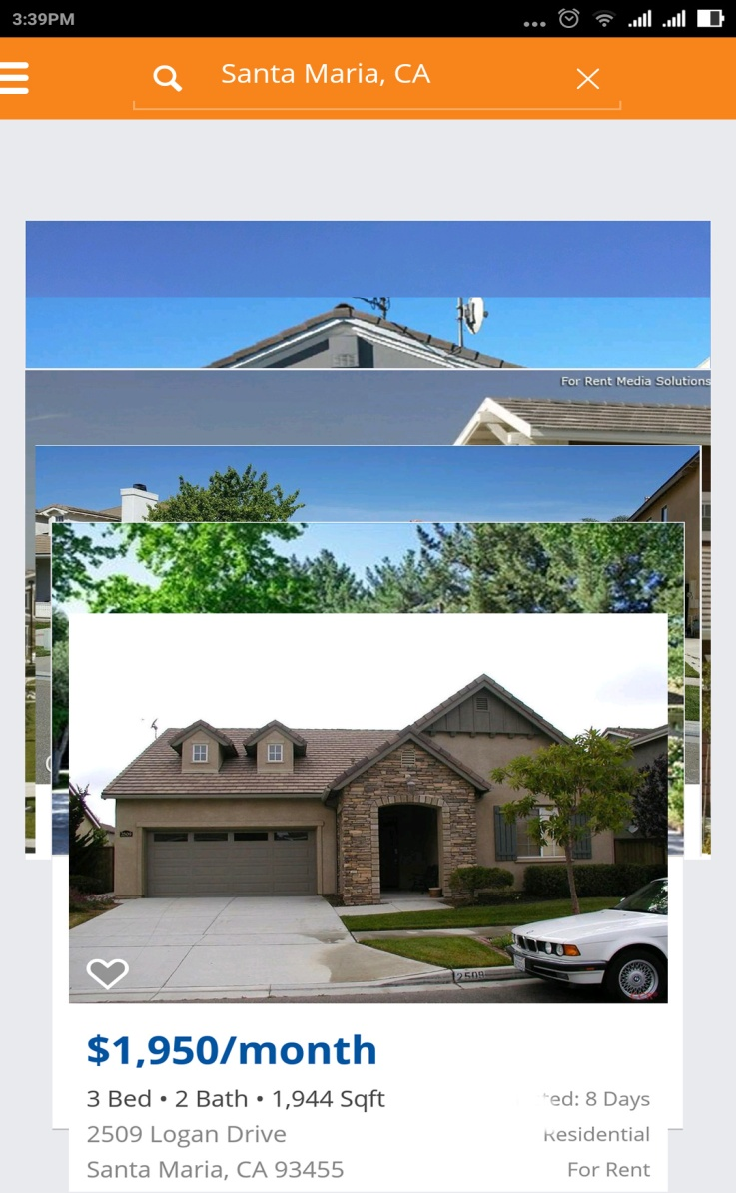

# Screenshot_2016-07-26-15-36-12.png

# How the app will work?

After user opens the home page, there will be two choices

* Looking for Tenant
* Looking for Landlord

From landlord view

After user clicks on ‘Looking for Tenant’, the app will be redirected to register/login page. Register page will have fields as email, password and confirm password. Proper validation messages will be displayed upon invalid entries in the forms. Login page will be validated through email and password. To seamless the registration and login functionality, we can use the social login feature like Facebook or Twitter or Google+.

After successful authentication, user will be landed to Dashboard page. Dashboard page will have list of past properties posted by self. User can view the property detail after click on the property list. Property detail page will also display list of tenants contacted, count of likes/dislikes…etc. Landlord can also send the Contract to the tenant from this page and also can chat with. All the chat history will be saved locally and will be displayed on demand in a separate view.

In the tenant profile page, the landlord will decide whether they would like to make further contact or dismiss the enquiry. Again this will involve swiping left or right. Swiping right will make further contact and a messenger service will appear for the two parties to discuss further.

Dashboard page will have some other capabilities like adding of property, view notifications, list of matched tenants…etc.

In the create property page, landlords can choose for some fields not to appear on the advertisement, some will be mandatory. At the same time landlord has the ability to upload the contract details right after the posting of advertisement. Landlord can send the scanned contract document within the app to tenants.

Landlord will get push notification when tenant click on ‘connect with landlord’. And when landlord click on that push notification, the app will be redirected to tenant profile page. And also in the dashboard page, there will be an option to view all the ‘matched’ tenants against properties.

Landlord will get push notification when tenant revert back with signed contract. This will also be displayed in the notification area. Landlord can keep a scan copy of the “Credit check” from the tenant on behalf of the property tenancy. There will be a settings page where user can change password/forgot password.

From tenant view

After user clicks on ‘Looking for landlord’, initially the app will fetch the user’s current location and display list of properties in stack view within certain miles. However, user has the ability to search property on desired location by inputting the text in search field. There will be another option for the user to show the properties in a map view with plotted pins. Non registered user can only search the properties. They cannot ‘like/dislike’ properties or contact landlords until they register with the app.

Register page will have fields as email, password and confirm password. Proper validation messages will be displayed upon invalid entries in the forms. Login page will be validated through email and password. To seamless the registration and login functionality, we can use the social login feature like Facebook or Twitter or Google+.

After successful authentication, user will be landed to Dashboard page. Dashboard page will display list of properties in stack view within certain miles as well as with map view option. Clicking into a property will show further photos and more information on that specific property.

User can swipe left to dismiss a property and swipe right to ‘connect with the landlord’. After dismissal of a property the next item will be displayed. When user clicks on ‘connect with the landlord’, the respective landlord will receive push notification about the ‘match’. Tenant can only chat with the landlord if he/she accept the chat request and all the chat history will be saved locally, will be displayed on demand in a separate view.

Tenant will get push notification whenever he receives a contract from landlord against a property. This notification will also be displayed in the notification area. Click on the notification the contract document will be opened within the app and asked for the signature. After signed the contract, the tenant can resend it to landlord. Tenant can scan a copy of the “Credit check” and send it to landlord on behalf of the property. There will be a settings page where user can change password/forgot password

Admin Portal

There will be onetime admin setup for logging into web portal. In the settings area user can change/forgot password. In the dashboard page, user can enable/disable a tenant or landlord. When admin disable a user, won’t be able to login to the app and all the properties posted by the user will be disabled. Admin can also enable/disable a properties too.

Web portal will have some standard report generation on following items,

* Cumulative view of registered users in month view (Landlord & Tenant)
* Cumulative view of new property added in month view
* Match count month wise

# Critical functionalities

* The UI and animation as defined by referring Tinder application is smooth and very nicely transitioned from one screen to another
* Open the contract document within the app and put the e-Signature
* Taking care of real time chat process where messages need to be stored locally

# Challenges for Development

1. **UI and Animations:** Making the animation effect smoother without affecting the flow and interaction of the user with application.

**Solution:** We have the most experienced team which can integrate this feature upon making several demos and eventually making it work.

1. **Chat:** Real time chat is a critical part of any chat application, especially handling messages in situations when the internet goes off.

**Solution:** This feature can be handled by storing the chat in cache for few second so that even if the internet isn’t on, the user’s typed chat will remain in cache and as soon as the internet goes on it fetches the chat from the cache and send it across.

1. **E-signature:** Putting the signature on the document within the app

**Solution:** We already have the expertise and we will use our free ***e-signature SDK*** on iOS to achieve this functionality

# Queries & Understandings

* Can a landlord become tenant against same property?
* Our understanding,
  + App will show the nearby property available for rent in the map view
  + Credit check will be taken care outside of the app